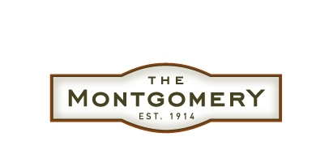

THE MONTGOMERY AWARDED
“BEST RENOVATION”
BY THE
SAN FRANCISCO BUSINESS TIMES
2007 DEALS OF THE YEAR
-Former Call Building singled out as winner in rehabilitation/renovation category-

SAN FRANCISCO (Mar. 28, 2008)- The Montgomery, a classic historic building from San Francisco’s past that has been restored as modern condominium homes, won the top prize for renovation in The San Francisco Business Times 2007 Deals of the Year contest.

Built in 1914 as the Call Building, The Montgomery has been re-launched in the 21st Century and beyond as the new home for 107 families. The project development team was lead by Mike Kelly, principal of MK Equities, along with the building owner, New Urban Properties.
A major conversion of this type cannot be accomplished without the contributions and cooperation of a great team of workers, consultants and professionals. Kelly’s development team consisted of the architects, Huntsman Architectural Group, and the project construction team at Cannon Constructors. The entire project was made possible by the construction lenders at National Electrical Benefit Fund

MK Equities specializes in acquiring and restoring classic buildings for modern use. Through a balance of restoration and preservation, MK Equities and their team respect and embrace the significance of the stewardship of these historic properties which contribute to the vitality of San Francisco. Other significant restorations include 445 Bush, 300 Brannan, 840 Brannan and several properties along Montgomery Street.

About The Montgomery
The Montgomery is San Francisco’s most exciting new residence -- an address where past and present literally converge. Built in 1914 as The Call Building and listed on the City’s historical register, the neo-classical landmark building recently underwent a $70 million conversion from office to residential. Today, it’s reborn as The Montgomery, a stunning mix of vintage+modern, featuring 107 contemporary studios and junior-, one- and two-bedroom condos, including a shared roof deck and four luxury penthouses providing some of the most spectacular views of the heart of San Francisco. The Montgomery is expected to close on all units in 2008. For more information, visit the sales center (open daily, 11 a.m. – 5 p.m., at 74 New Montgomery St.), call (415) 512-7474, or go online at www.themontgomerysf.com. For more information on MK Equities visit their website at www.mkequities.com or call 415/398-9200

###

